

Inside this issue:

Special Dates this Month 2

At Immanuel 3

Around Us & With Us 3-4

The Lutheran Hour 5

“Strengthened by God’s Word and Sacraments,
our mission at Immanuel Lutheran Church is to
radiate our spiritual faith in Christ by proclaiming
the Good News of Salvation and
God’s love for all people.”

J
U 2
N 0
E 0
8


Minister
Pastor Chris Matthis
office: 303-781-5887

Congregational President
Mr. Ray Gray
home: 303-973-5092

Head Elder
Mr. Rick Ryder
home: 303-761-1710

Church Secretary
Mrs. Connie Benko
Office hours:
10:00 AM – 3:00 PM,
Tuesday – Friday

Immanuel Lutheran Church
The Lutheran Church - Missouri Synod
Phone: 303-781-5887 Email: Godwithus@qwestoffice.net
Website: www.Luther95.com/ILC-ECO

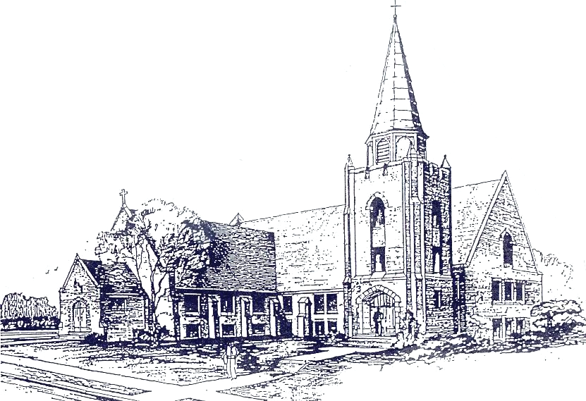
Sunday

10:00 a.m.
Worship
Service

Sunday

8:30 a.m.
Sunday School


SPECIAL DATES IN JUNE


4 – Audrey Stark
7 – Joanne Ibsen
10 – Corey Egan
11 – Ginny Peister 14 – Josef & Lavona
11 – Lois Titus Klapper (58)
16 – Colin McCorkle
16 – Al Peister 23 – Steve & Kathy
23 – Stephen Mains Mains (28)
25 – Riley Day
27 – Geri Gray
27 – Ed Haworth
29 – Lester Germann

11 – ST. BARNABAS, APOSTLE
14 – Flag Day
15 – Father’s Day
20 – Summer Begins
25 – THE PRESENTATION of the AUGSBURG CONFESSION, 1530
29 – ST. PETER and ST. PAUL, APOSTLES

Page 2

AT IMMANUEL…

We Lift Them Up Unto the Lord…

Immanuel – Praise God in thanks for all that He continues to do for us, through us, and with us. Pray that He will guide us in the way in which He would have us go and that we will be given the richness of faith to trust in His care and provision. We have truly been blessed!
GOD IS GOOD!

Little Ones – Thank God for the gift of our little ones – we have 10-12 children going up for the children’s message on Sunday mornings. Pray that He will help these children follow Jesus according to His good and gracious will, and for His blessings on us as we share the Way with them.

Movie Night – June 22nd is an evening open for everyone to come eat a bite and then enjoy the movie of the evening! The movie will be announced at a later date. There will be games and activities for the children, too! So leave Sunday, June 22nd (5:00 p.m.) open for a good time with the Immanuel gang.

Around Our District…
Praises
Calls Accepted for Church Planting Project – We praise God that two pastors have accepted calls to serve as church planters in our District. Rev. Robert Harmon has accepted the call to serve at Faith, Las Cruces. Rev. Alan Borcher has accepted the call to serve at Light of the Valley, Riverton, UT. Please continue to hold these men and the respective missions in prayer as they begin this new chapter.

We also pray for the three missions still seeking church planters. Abiding Word, Falcon, CO has called Rev. John Palka. Cross of Christ, Aurora, CO and Shepherd of the Hills, Rio Rancho, NM are reviewing additional candidates in preparation for extending their next calls. We pray that God, the Holy Spirit, would continue to guide the process of calling the men whom He desires to lead these missions.

Page 3
Family of Christ, Frederick, CO – We thank God for the successful kidney transplant from Rev. Jeremy Jacoby, pastor of this congregation, to a member, Jon Adams on April 29th. Pastor Jacoby was tested and learned that he was a good match for the transplant for this new member of the church, whom he had known for only about a year. We praise God for the heart of love that
moved Pastor Jacoby to offer this sacrifice and for the witness it bore to the community. We pray that both Pastor and Jon may recover quickly and continue in good health.

Developer Hired for Lutheran Hispanic Missionary Institute – Paige Matthews has been hired as the Development Director for this Institute, which has as its purpose the training of workers for Hispanic ministry. His task will be to raise partners throughout the District and Synod to support the work of this school. We pray that God would bless Paige’s work to provide the resources for this exciting ministry.

Petitions

Conversations of Grace Web-Conference – We remember this upcoming conference, scheduled for November 8th of this year in our prayers. We are excited that the Kansas District will be a co-sponsor this year. The plan is to broadcast this conference via the internet to local venues throughout the Rocky Mountain and Kansas Districts. The purpose of the conference this year will be to help congregations develop or enhance their outreach plans. We pray that God would bless the Evangelism team as they face the challenges of developing this conference, which is new both in terms of format and content.

LWML Convention – We pray for the upcoming Rocky Mountain District LWML Convention scheduled for June 20-22 at the Embassy Suites in Albuquerque, NM. (You may find more information at www.rmdlwml.org.) Please pray for the Lord’s blessing upon this gathering and these women committed to the spreading of the Gospel in our District and throughout the world.

Page 4

Radio Program
June 1
"Making the Cut"
Speaker: Rev. Dr. Ken Klaus
Following the Savior is more than knowing His Name. Today's message on "The Lutheran Hour" speaks to what is necessary to enter the kingdom of heaven. (Matthew 7:21)
June 8
"Bad Company"
Speaker: Rev. Dr. Ken Klaus
Jesus was judged by the company He kept. Can that be said for the Savior's followers?
(Matthew 9:11)
June 15
"A Worthy House"
Speaker: Rev. Dr. Ken Klaus
Today's Lutheran Hour message answers the question, "With the traditional family dissolving what constitutes a worthy house?"
(Matthew 10:13)
June 22
"That Sounds Fair"
Speaker: Rev. Dr. Ken Klaus
Share the Savior or sit tight? Easy to say, hard to do. Listen to "The Lutheran Hour" locally on STATION at TIME or on the Web at www.lutheranhour.org. Hear the broadcast available to our military at: www.lutheranhour.org/AFN/listen.htm. "The Lutheran Hour" is also on XM's Family Talk Radio 170 every Sunday at 1:00 p.m. (EST).
(Matthew 10:32-33)
June 29
Guest Speaker: Rev. Kurt Taylor

The Lutheran Hour is broadcast every Sunday morning at 6:05 a.m. on KOA 850 AM, or by free podcast download on iTunes.

Page 5

